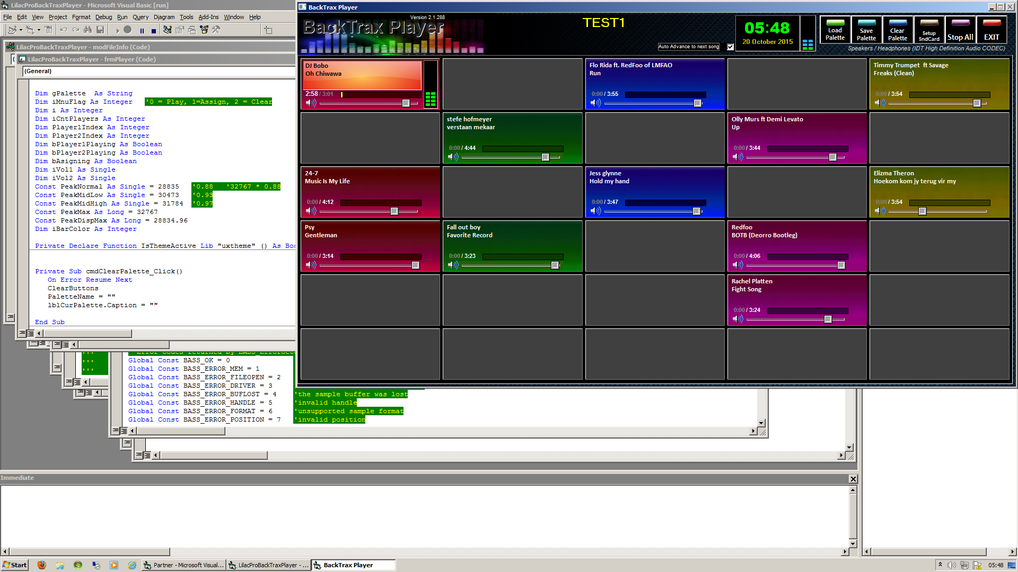

**Introduction**

The BackTrax Player app was designed very specifically with playing backing tracks or show music tracks in mind. It is a very basic but very functional little app. It well runs on all new 32 bit/64bit Windows platforms. It will also respond with touchscreen technology, since it was designed with that in mind. It uses BASS technology to play the tracks, and can play virtually any format (mp3, wav, mp4, flac, aac etc).

The app uses the tags of the files to display on screen, but where no tag is found, it will display the filename info. It does have limited tag update features, and therefore would suggest tagging mp3 files properly before using the app as a must.

**Getting started.**

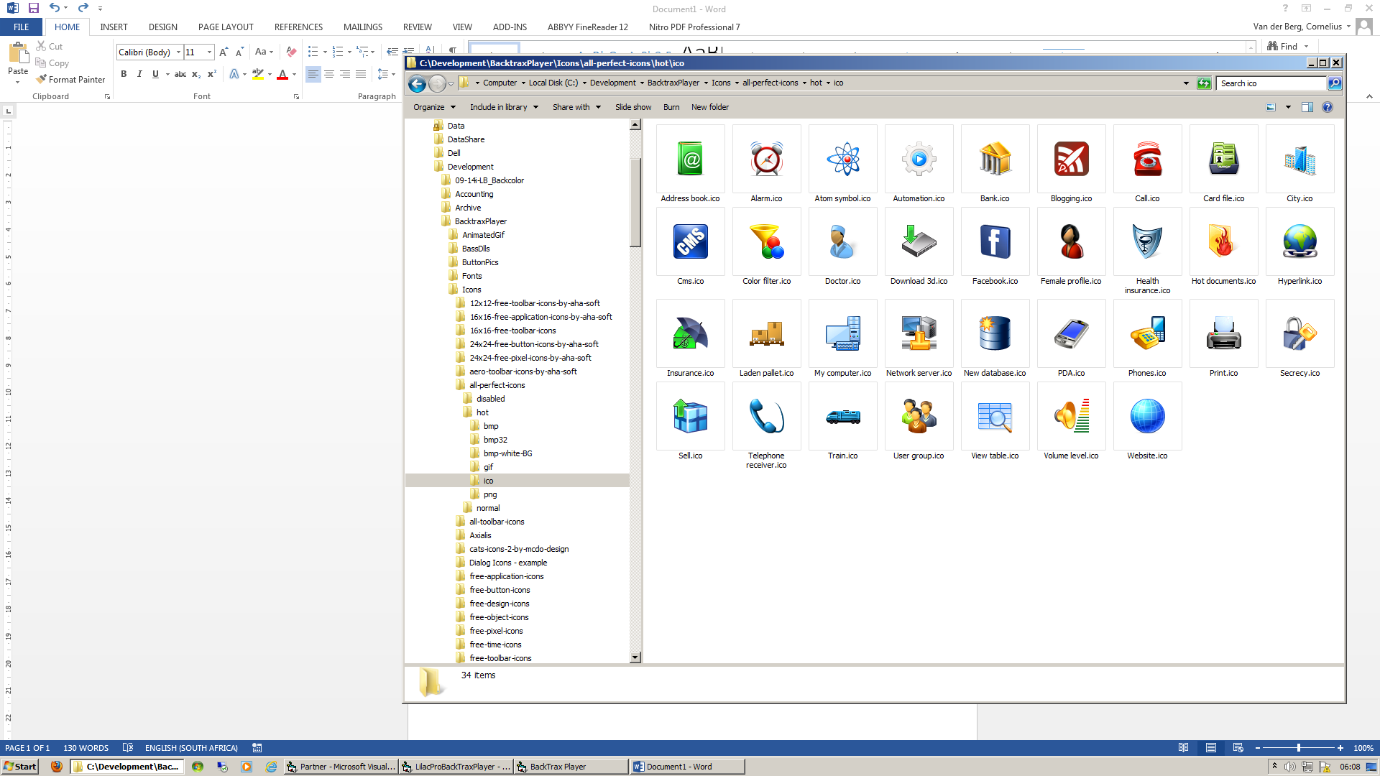**Launch the app from the icon on screen. It will load the player screen. If a previous playlist have been created, and last played, it will load as a default. Otherwise the screen will be blank.**

* The player consists of 6 rows by 5 columns, giving a total of 30 available tracks. Each of these 30 buttons can be moved with drag and drop to any location in the player, with the exception of the button which is currently playing a track.
* The screen can be seen as a playlist, and multiple playlists can be saved and recalled at any time. If a song is playing, the new playlist selected will reload all the other buttons, but leave the current one playing till the end, and NOT overwrite the content of it.
* Any button can be assigned a colour of choice, limited to the 6 colours in the app.
* Any button’s contents may be cleared at any point, again with the exception of the button of the song being used at that point.
* The playlist can be cleared at any time, making space to load new songs into the buttons
* Each button has its own volume control, and when loading a song, it will determine the average max volume of the song and adjust the slider accordingly. This can be changed at any time.
* To play a song, simply click on the left top portion of the button. To stop, just click again in the same area.
* To access the menu portion of the button, simply click on the right, bottom corner area.
* The menu has an exit button in order to cancel any operation.
* The app also has the ability to assign to a specific soundcard, other than the default system soundcard.
* It can play 2 tracks at the same time, in order to overlap silences at the end of a track.
* When a song is nearing the end, the button will start blinking 10 seconds before the end of FILE is detected.
* While the song is playing, the time indicating scroll area can be clicked on to jump forward or backward in the song.
* An auto advanced option has been added to automatically play the next track at the end of the current track. It will play from top to bottom first, left to right. This option is only available if the track played, is utilising the first audio stream. It was added as an afterthought and some more developing could change this functionality.
* The playlist name will be displayed at the top of the screen, and the current time as well.
* When closing the app while a song is playing, a warning message will prompt to stop playing.

**Setup a sound card**

To setup the soundcard, click on the Setup SndCard button.

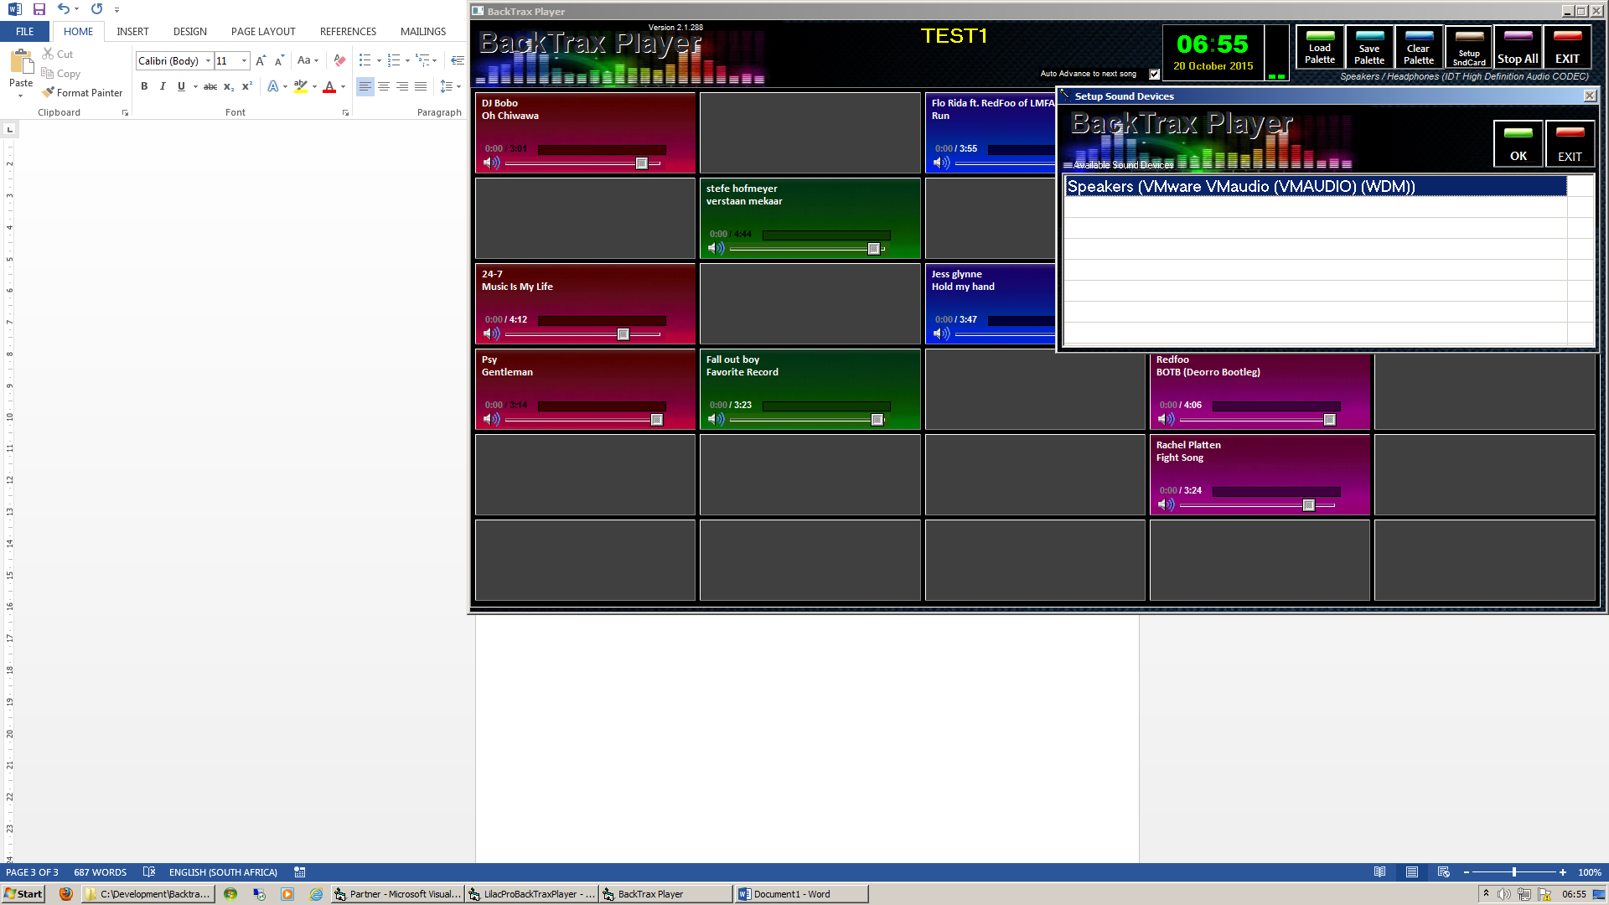All the soundcards will be listed here. Click on the required sound card and click OK.

It will re-evaluate all the songs on the playlist, since it needs to build the sound-card’s id into each song. This normally only takes a second or 3. The selected soundcard will be displayed on the playlist.

**Loading a song**

To load a song, simply click on any open button (Dark grey with NO text). It will launch the explorer list where the songs are stored.

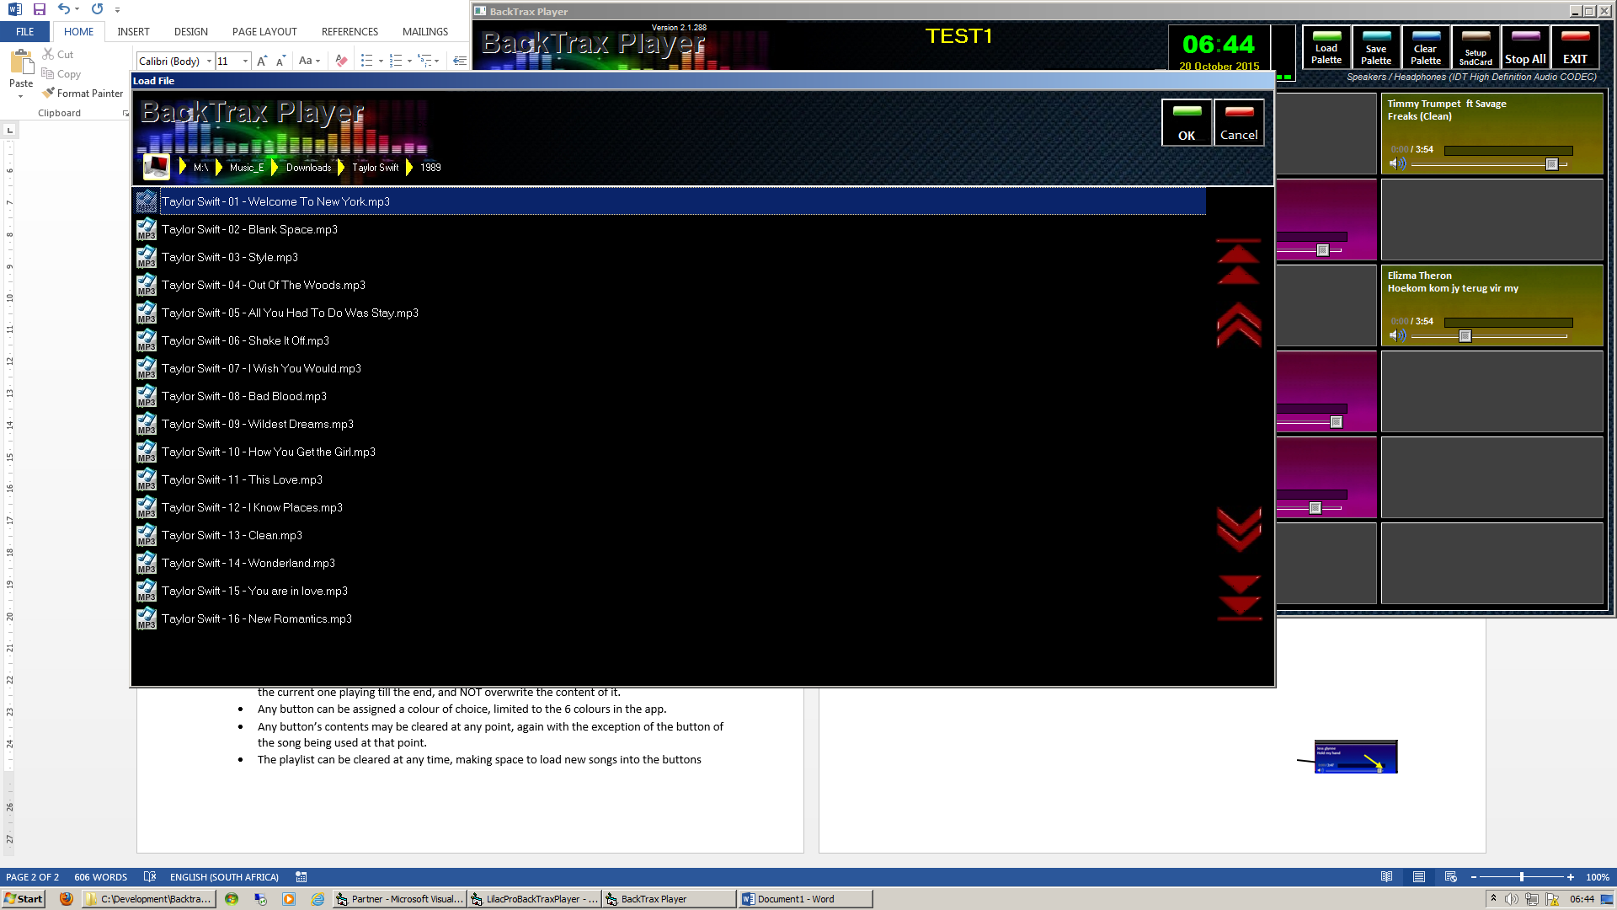

*Please note this may sometimes load slowly since it browses through the selected directory and lists* ***only*** *music files. To select a song, click on the song and click OK. It will close the explorer screen and load the song into the button from where it was launched.*

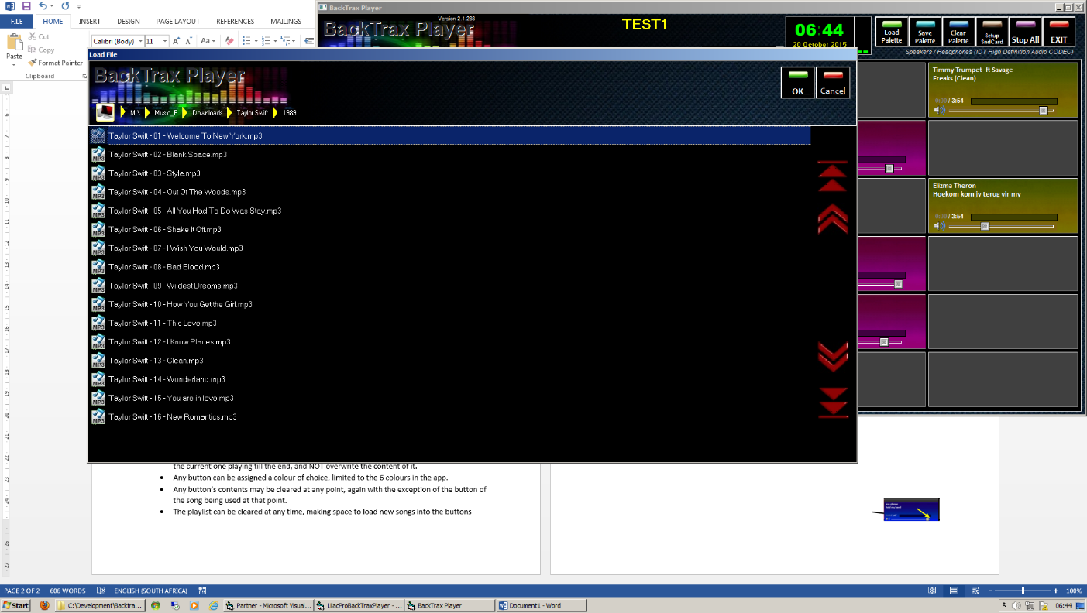To navigate the explorer, use the top menu items to load other directories. Clicking once in this area, will load **that** directory’s contents. You can now choose any other song from the list.

**Saving and Recalling Playlists/Palettes**

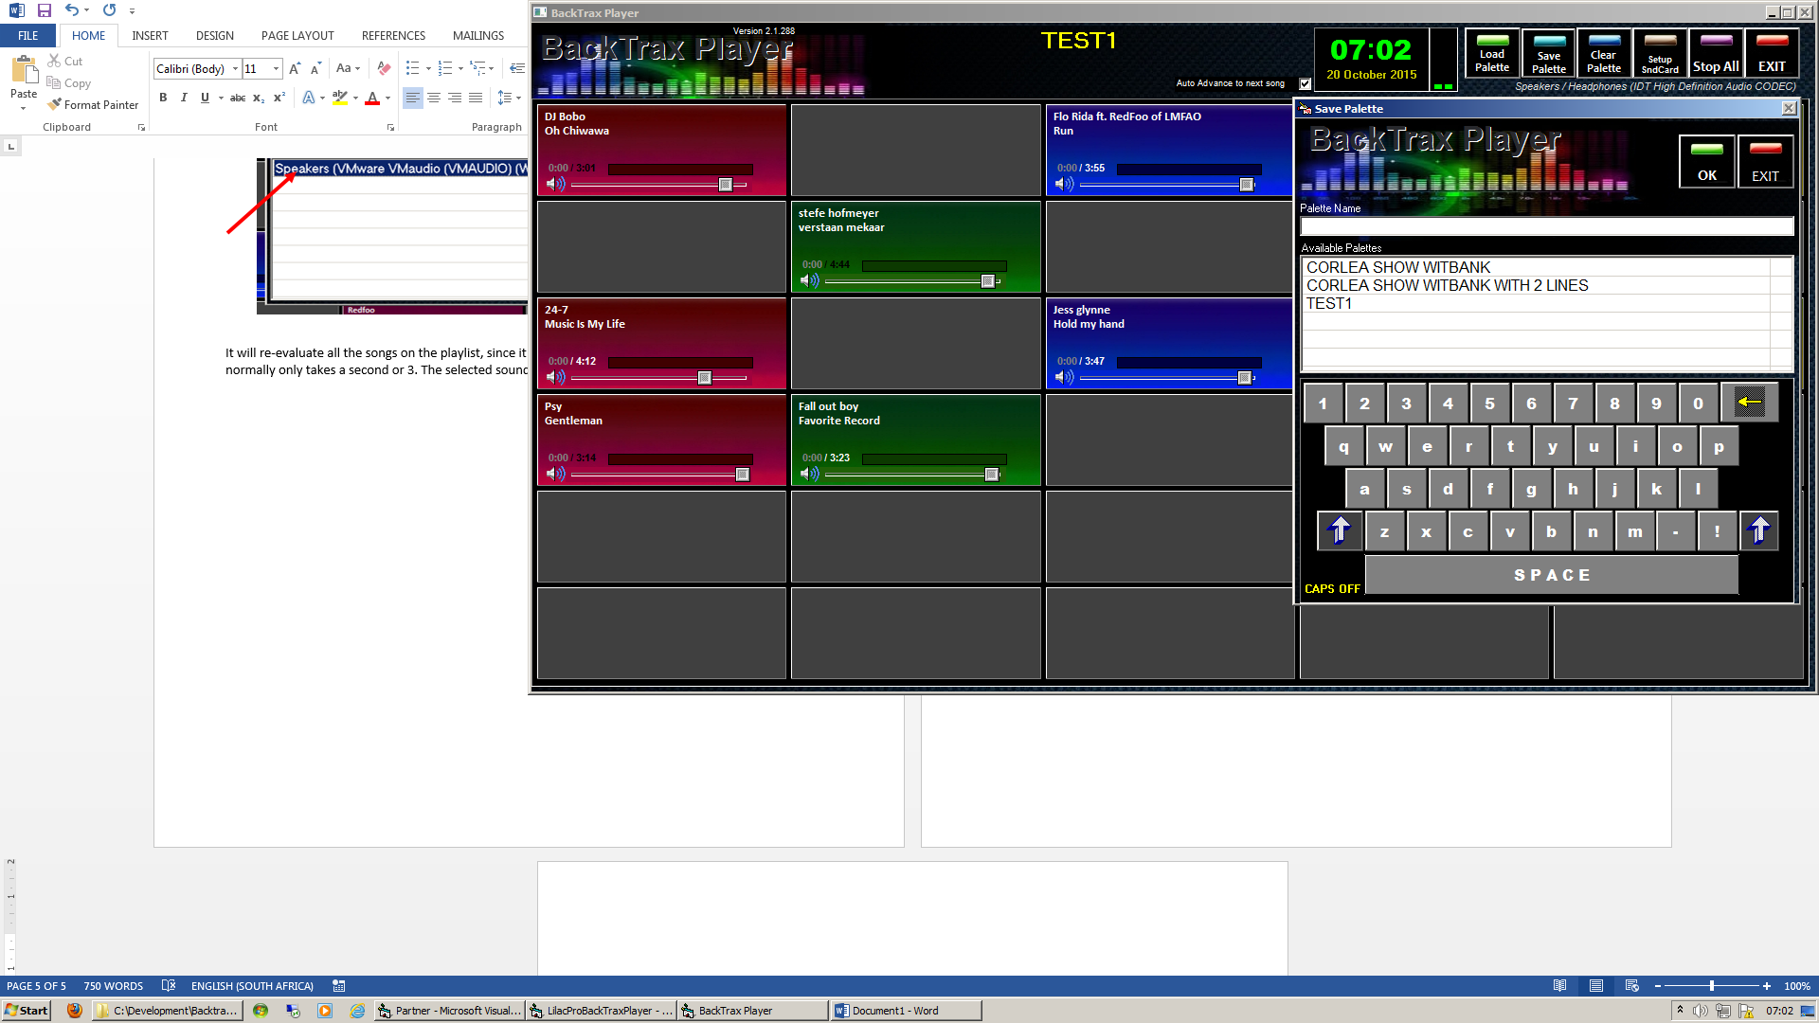To **SAVE** a playlist, select the Save Palette button from the main screen. It will open a screen where you can type a new name for this playlist. You can use the keyboard, or for touchscreens, use the on-screen keyboard.

This will save ALL the buttons with songs loaded at that time, as well as the colours and volume settings for each song. It will also record the positiion of the button.

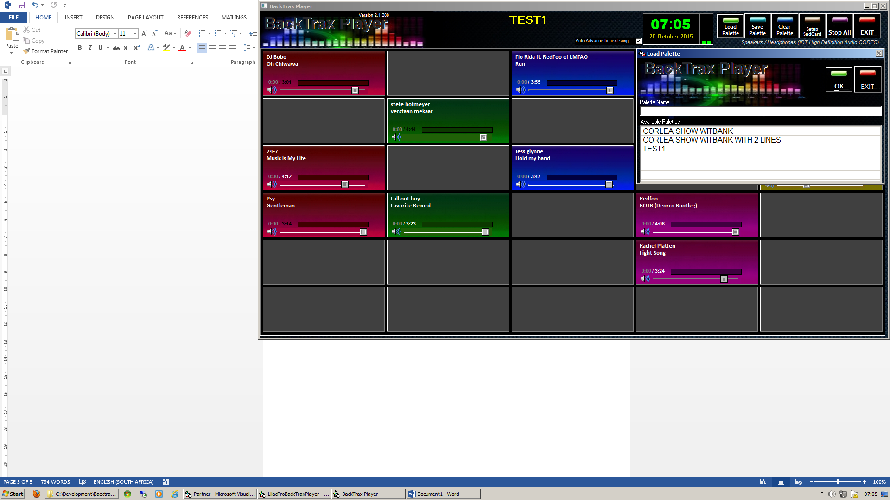To **LOAD** a previously saved playlist, simply click on the Load Palette button, and select any of the entries in the list.

This will load all the buttons that was saved associated with this list. The positions, colours as well as the volume levels set when it was saved, will also be recalled.

**Playing the songs**

The player can play 2 songs at any given time. When a song is playing, only the volume level can be adjusted. To change colours, or selecting a new song, the button needs to be in a STOPPED state.

To play a song, simply click on the left top portion of the button. To stop, just click again in the same area.

The volume may be adjusted during playback. When the playlist is saved, this volume level will be saved.

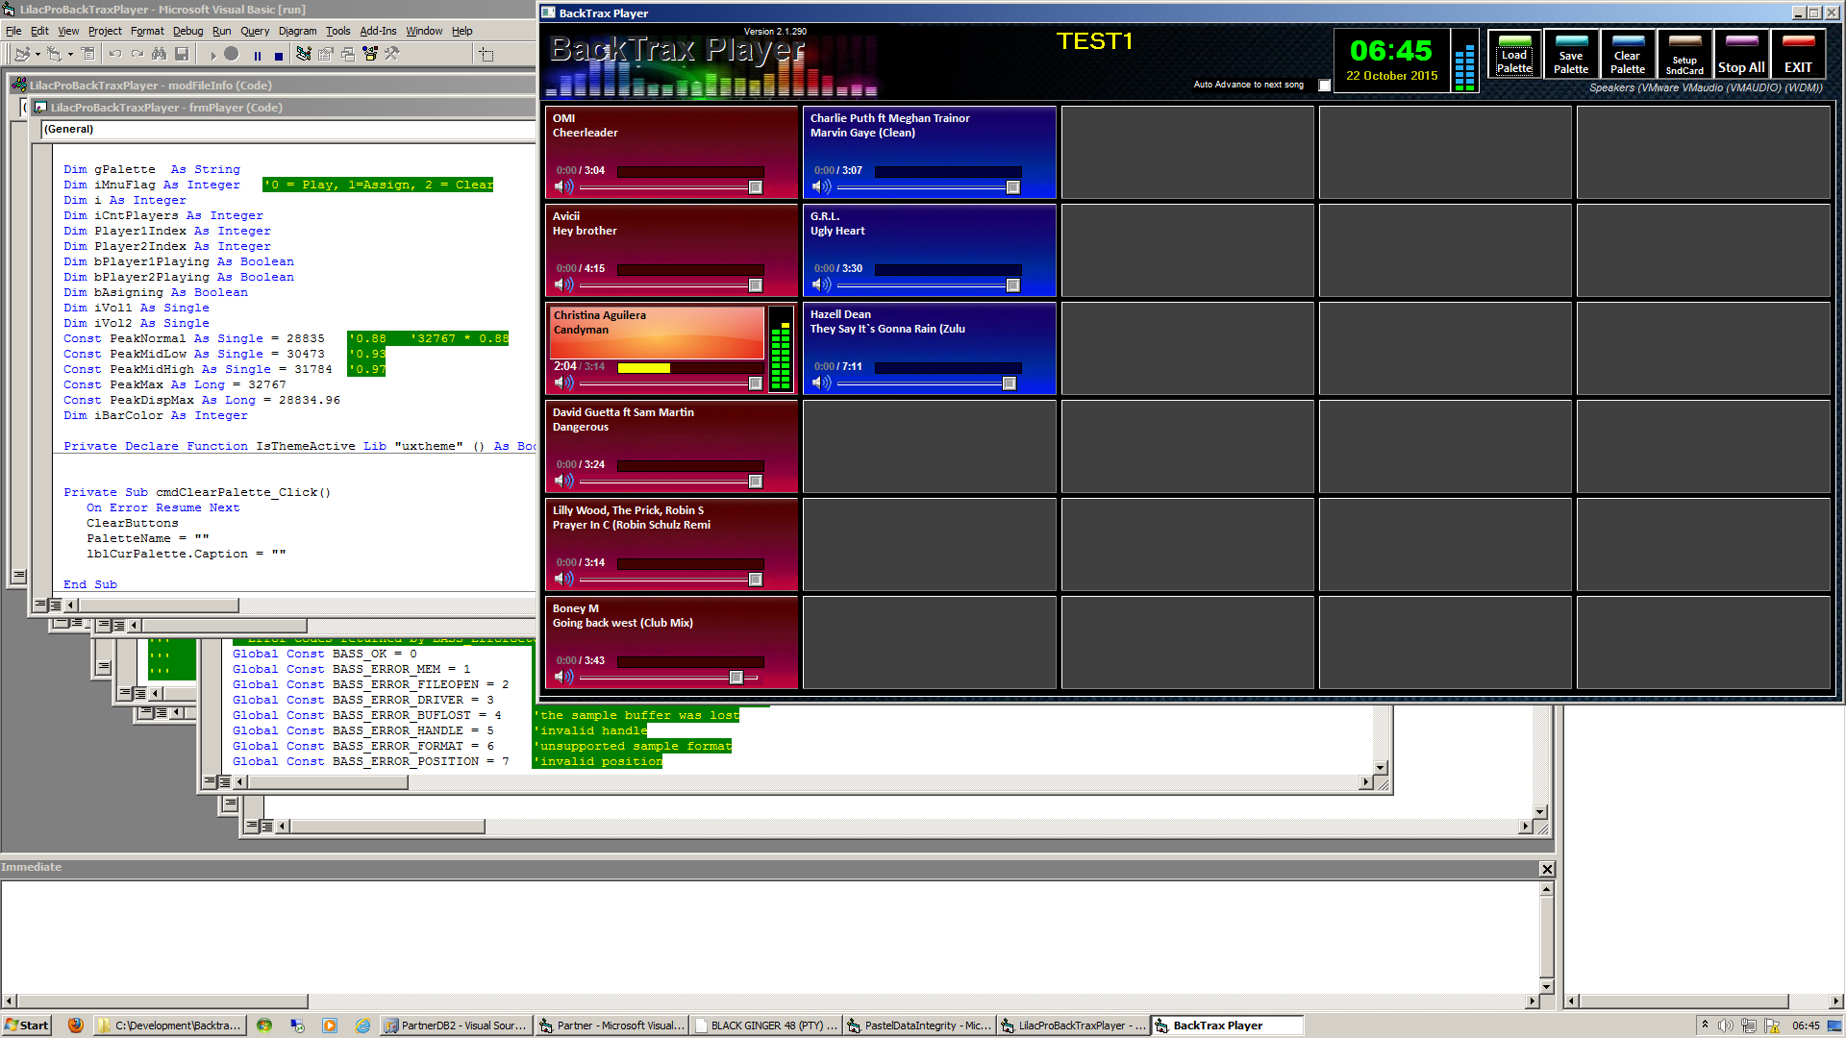While a song is playing, the position of the playing may be adjusted by clicking on the position scrollbar. The song will jump to that position and continue playing till the end.

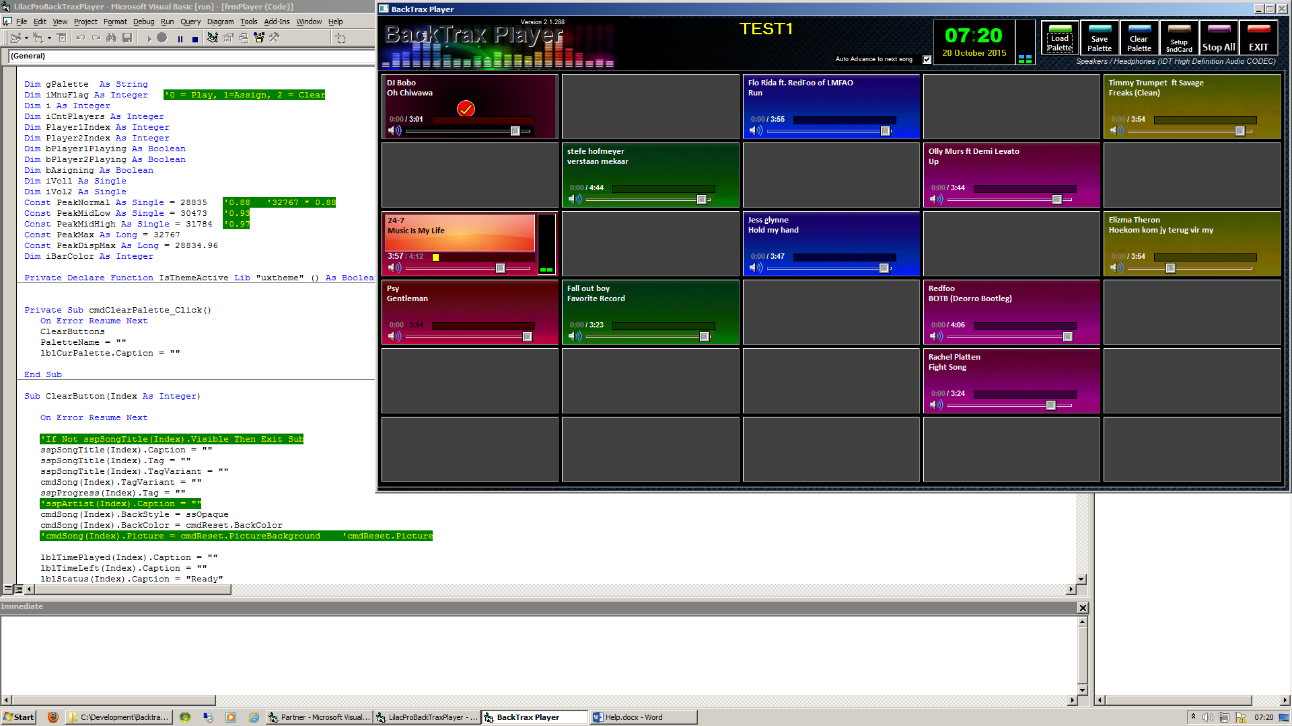When the end of a song is neared, the button will start blinking at half a second intervals, for 10 seconds. At the end of playback, the song will stop, and all flags and playing colours will be reset. The picture/colour will the change to “played” background. Any song can be replayed, irrespective of the colour or played state.

**Auto Advancing**

If the track is playing in the first stream space, and the Auto Advance to Next song option is checked, the next song in the playlist will automatically start playing once the previous song has stopped. This only applies if the song stops on its own. If the user stops playback, this does NOT apply anymore.

**Changing Button Colours**

Each button can be assigned a different colour, available from the colour menu. This menu can be accessed by clicking in the right-hand portion of the button.

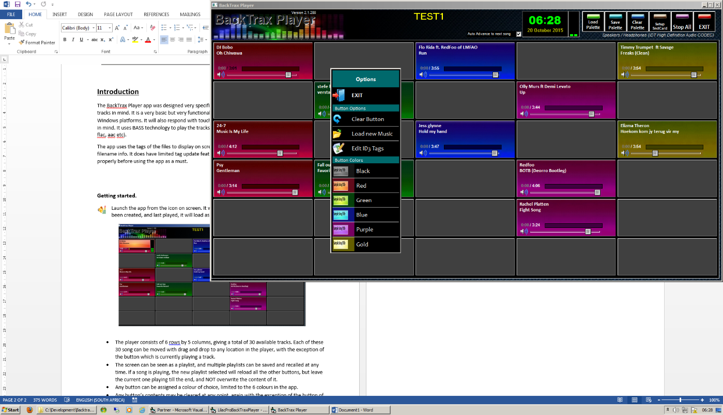A menu screen will pop-up near this button and the colour selection can be accessed.

Click on the desired colour, and the menu will disappear and the button colour changed to the selected colour. This option can be changed any time while a button is NOT “Playing” and this colour settings will be stored when the Save Palette option is used.

*PS. If you add a new button, or change a colour or volume, and do* ***NOT*** *save the list, this entry will not be available when you recall the list.*

**Clearing a button**

The **CLEAR Button** option is also available here to clear out the contents of the desired button. This includes, colour, volume as well as song content.

**Load new Music**

The Load New Music option is also available on this pop-up menu. It allows the user to clear-out and select a new song to an already assigned button. All previously discussed loading procedures applies when this option is selected.

**Edit ID3 Tags**

To edit MP3 tags, select this option. It is very limited at this stage, so creating proper ID3 tags before using the app is recommended.

***Please note that this facility is NOT intended for the general creation or fixing of tags, but merely a helpful tool for those quick unforeseen times you quickly have to change a tag. This is only available for MP3, and will only save ID3 V1 tags and not V2…***

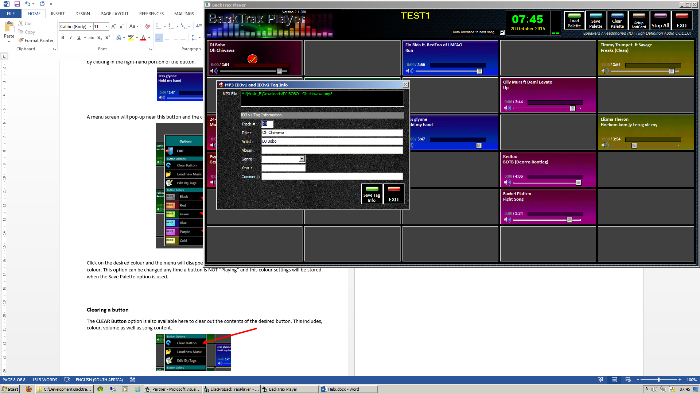Selecting this option, loads a new screen with the current ID3 v1 tag information

Type the relevant information and click Save Tag Info. This new tag info will be loaded into the button.



*Although the software is free of charge, it still takes a development team to make this product possible, and they all need to be paid. A donation of therefore will be greatly appreciated.*

*Please use the following bank account to deposit any donation towards the development and improvement of this software.*

Acc. No: 42 601 732 3



For any feedback, requests, enhancements or errors, please email the developments team.

**lilacpro@gmail.com**